ENGR-UH 1000
Computer Programming for Engineers

TERM PROJECT
POSTURE SMART
SOFTWARE REPORT

Name: Ibrahim Bucktowar, Shadad Hossain, Sarfraz Binushkhan

Introduction
Proper posture is a critical yet often overlooked aspect of health and well-being. With increasingly sedentary lifestyles and the prevalence of desk work, improper posture has become common. Incorrect posture refers to an abnormal body state where the body cannot maintain stability or the normal function of tissues and organs in an upright position (Dolphens et al., 2012). Studies show that poor posture habits in adulthood are often rooted in childhood (Louw et al., 2007). Severe posture issues in children and adolescents may progress to adolescent idiopathic scoliosis, causing an abnormal lateral curvature of the spine (Nissinen et al., 1993; Nault et al., 2002). Additionally, untreated incorrect posture has been linked to reduced cardiorespiratory efficiency, decreased lung capacity, low back pain, and displacement of internal organs. For students who spend extended periods sitting while studying, failing to develop good posture habits early can make correcting these issues later in life extremely challenging (Lompoc Valley Medical Center, 2021) and make them susceptible to the aforementioned conditions.
Maintaining good posture is essential for evenly distributing stress across muscles and ligaments, reducing wear and tear on the joints (Cleveland Clinic, n.d.). Beyond physical health, good posture offers significant mental health benefits. Research indicates that maintaining proper posture can boost mood and confidence, regulate mood swings, and reduce negative thoughts (Peper et al., 2014). It also enhances mental clarity and composure, which are crucial for maintaining focus and achieving better performance in academic settings (National Geographic, n.d.; LWW Journal, 2023).
The POSTURE SMART project addresses these concerns with an innovative wearable device designed using the Adafruit Circuit Playground Classic. This all-in-one posture monitor helps students maintain proper posture, encourages regular movement, and improves focus during study sessions. By tackling postural issues early, the project aims to prevent chronic problems and foster healthier habits, ultimately contributing to improved health outcomes and academic success.
To further support students, the project incorporates a Pomodoro Timer and a Focus Mode (Sound Level Detector). The Pomodoro Timer alternates between 30-minute focus sessions and 5-minute breaks, helping students sustain productivity while avoiding burnout. The Sound Level Detector ensures users remain in a quiet environment conducive to concentration. If the user starts talking or if excessive noise is detected for extended periods of time, the system alerts them to refocus or move away from distractions.
Together, these features create an optimal atmosphere for studying and help improve focus and efficiency.

The project objectives are as follows:

- Develop a wearable device using the Adafruit Circuit Playground Classic that accurately detects and alerts users to poor posture in real-time.
- Implement a sitting tracker feature that reminds students to take regular breaks and engage in physical activity.
- Create a focus monitor that detects noise levels and notifies users of potential distractions, promoting a distraction-free study environment.
- Ensure the device is comfortable, unobtrusive, and suitable for extended wear during study sessions.

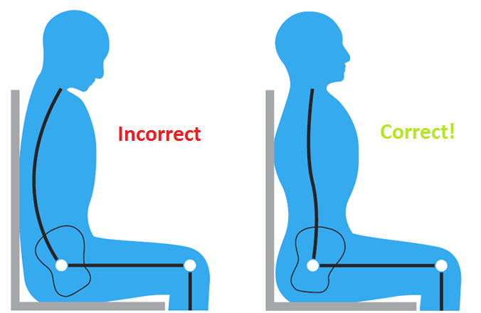
Figure 1: Incorrect vs Correct Posture while seated

Project Development

Project Tools:

Adafruit Circuit Playground Classic:
The Adafruit Circuit Playground Classic is an all-in-one microcontroller board designed for beginners and advanced makers alike. Powered by an ATmega32u4 microcontroller, this board was instrumental in our project due to its wide array of sensors and built-in features, enabling quick prototyping and experimentation without requiring additional components. We utilized the following capabilities of the device.
- Built-in Sensors: Utilized the accelerometer, sound sensor (microphone), and a push-button switch.
- Integrated Outputs: 10 RGB NeoPixel LEDs, and an onboard red LED.
- Input Options: Two user buttons.
- Connectivity: USB for programming and power.
- Power Options: Operates via USB connected to power source (e.g power bank, laptop)
- Compact Design: A 2-inch diameter board ideal for wearables.
Arduino IDE:
The Arduino IDE is an open-source platform for writing, debugging, and uploading code to microcontroller boards. It supports various boards, provides a straightforward interface, and includes a rich library ecosystem. There is an active community of Arduino users who frequently post tutorials and projects on the adafruit website. These tutorials were an integral part of the development process as well.
C++ Coding Language:
C++ is a high-level programming language widely used for microcontroller programming. It offers control over hardware and is compatible with the Arduino ecosystem.

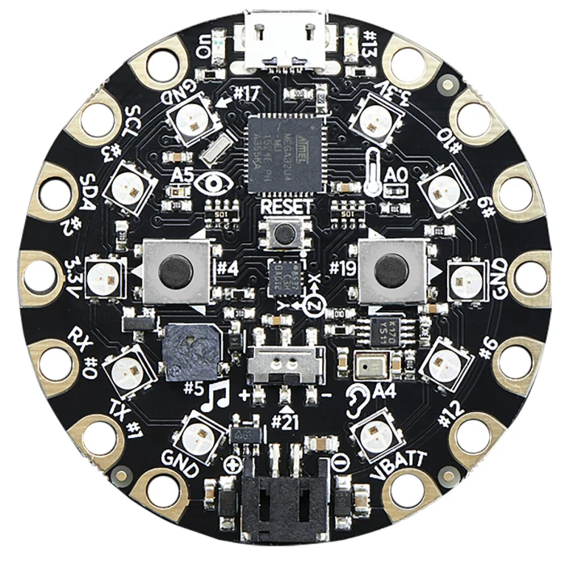
Figure 2: Adafruit Circuit Playground Classic

Posture Smart Features
The different features are represented with classes as shown below:

1. Posture Corrector
Purpose: Monitors the Z-axis acceleration of the device to detect significant deviations from the normal gravitational constant, indicating poor posture. Provides alerts to encourage immediate correction.
Private Variables:
None required, as the feature directly monitors real-time accelerometer data.
Public Members:
- zThreshold: The acceptable deviation in Z-axis acceleration from 9.8 m/s² (gravitational constant).
- enabled: Boolean flag to indicate whether the feature is active.
Methods:
- update(): Continuously monitors the Z-axis acceleration and triggers an alert if the deviation exceeds the threshold.
- begin(): Initializes any required settings (not directly implemented in this iteration).
Workflow:
- Continuously samples the Z-axis acceleration using CircuitPlayground.motionZ().
- Converts the raw acceleration data from G to m/s² for accuracy.
- Compares the measured Z-axis value against the gravitational constant (9.8 m/s²).
  - If the deviation exceeds the defined zThreshold, it identifies poor posture.
- Alerts the user with:
  - A 1000 Hz tone for 200 milliseconds using the onboard speaker.
  - Red illumination of all LEDs to provide visual feedback.
- Alerts are temporarily disabled during the mute period to avoid redundant notifications.
- Provides a brief delay to manage alert frequency and avoid overwhelming the user.
This workflow ensures the user receives immediate feedback for poor posture, encouraging timely correction and promoting ergonomic habits.

2. Sound Level Detector
Purpose: Monitors the surrounding sound pressure level over time, visually displays volume intensity, and provides alerts if the average sound level exceeds a specified threshold.
Private Variables:
- accumulatedSound: Tracks cumulative sound levels
- readings: the number of readings
- lastAverageTime: the timestamp of the last averaging period.
Public Members:
- soundThreshold: Maximum acceptable average sound level.
- averagingTime: Time duration over which sound levels are averaged.
- enabled: Boolean flag to indicate whether the feature is active.
Methods:
- update(): Reads sound levels, calculates averages over the defined time period, and triggers an alert if the average exceeds the threshold.
- displaySoundLevel(float soundLevel): Uses blue LEDs to visually represent the current sound level, mapping the intensity to the number of illuminated LEDs.
Workflow:
- Continuously samples sound levels using CircuitPlayground.mic.soundPressureLevel().
- Maps the sound level to a range of 0–10 blue LEDs to provide immediate visual feedback on the environment's noise intensity.
- Accumulates sound data and computes the average over the defined averagingTime.
- If the average sound level exceeds soundThreshold:
  - Emits two beeps through the onboard speaker.
  - Illuminates all LEDs in red to indicate excessive noise.
- Resets cumulative data after each averaging period.
Real-Life Example:
Imagine a student using this device while studying in a library. The device provides real-time visual feedback about the noise levels. If a sustained period of high noise is detected, the device alerts the student, prompting them to switch to a quieter location.

3. Break Reminder
Purpose: Encourages users to take periodic breaks to reduce fatigue and promote physical well-being.
Private Variables:
- lastReminderTime : Tracks the timestamp of the last reminder.
Public Members:
- interval: Time interval between successive break reminders.
- enabled: Boolean flag to indicate whether the feature is active.
Methods:
- begin(): Initializes the break timer by setting the current timestamp.
- update(): Monitors elapsed time and triggers an alert when a break is due.
Workflow:
- Starts a timer based on the user-defined interval.
- Continuously monitors the elapsed time using millis().
- When the defined interval is reached:
  - Emits a triple beep using the onboard speaker.
  - Illuminates all LEDs in red to signal a break reminder.
- Temporarily mutes all other features during the break period to avoid overlapping alerts.
- Resets the timer for the next cycle.
Real-Life Example:
A software developer uses the device during long coding sessions. Every 30 minutes, the device reminds them to take a short break, reducing eye strain and promoting better posture.

4. User Interactivity
Purpose: Allows users to customize the device’s functionality through an intuitive and engaging setup process.
Workflow:
- Feature Configuration:
  - At startup, the device enters configuration mode, indicated by the blinking of specific LEDs (0–2) representing the features:
    - LED 0: Posture Corrector.
    - LED 1: Sound Level Detector.
    - LED 2: Break Reminder.
  - Users toggle features on or off using the left button. The LED turns green for enabled and white for disabled.
  - Users confirm their selection and proceed to the next feature by pressing the right button.
- Reset Functionality:
  - Holding both buttons for over two seconds resets the device, returning it to configuration mode for feature re-selection.
- Mute Period:
  - During active breaks, all alerts are muted for a predefined duration to ensure uninterrupted relaxation.
Real-Life Example:
A teacher using this device in a classroom can enable only the sound level detection feature to monitor noise levels while keeping other features disabled. The device offers the flexibility to adapt to different scenarios and user preferences.
This modular and user-friendly design enhances the device's practicality, making it suitable for diverse environments and individual needs.
Note: The update function for each class is called repeatedly in the void loop outside the classes. On each iteration, this function (void loop) checks if the buttons have been pressed for reset. Then, if it is not the case, it checks if the program is within the mute period and the update functions are called. If the respective functions are not enabled or the current time is within the mute period, then the update functions return void.
The setupfeatures function are used for first time use or after a reset. It is responsible for the selection process of each feature. It loops through each feature, blinking in white and waiting for the user to select the option. The user can select or deselect any feature- an odd number of presses would be recognised as a selection and an even number of presses would be recognised as a deselection. A green light would indicate that the feature is activated and white otherwise. The choice recorded is then passed to the enabled boolean variable respective to each class.

Pseudocode

Define Posture_led as 0 // this is the index for the posture feature
Define Sound_led as 0 // this is the index for the sound level feature
Define Break_led as 0 // this is the index for the break reminder feature
Define Mute_duration as 300 000 // which corresponds to 5 in minutes

Create the posture class
Public members:
Declare zThreshold as a float
Declare enabled as a boolean

Create the constructor and initialize the zThreshold to 30.0 and enabled to
false.

Create a loop called update which takes a boolean ismute as argument
If enabled is false or ismute is true, then return

Get the z-axis acceleration value and pass it to a float z,

Convert this value from g to meter per second squared

Print this value to the serial monitor

If absolute value of the difference between this value and 9.8 is
larger than the threshold, then emit a beep sound, and light up all the
leds in red once with a delay of 2 seconds after the beep

Create the SoundlevelDetector class
Private members:
Declare lastAverageTime of type unsigned long
Declare accumulatedSound as a float
Declare readings as integer

Create a void loop function which takes soundLevel as an argument of type float
Clear the pixel colors
Map the sound level from 10 to 100 to the leds 1 to 10, assigning the value to
numLeds. //the sound level will be defined in the update function below

Check for each led form 1 to 10, if the index is within the bounds defined by
the mapping above, then light it up.
Else, switch off

Public members:
Declare soundThreshold as a float
Declare enabled as a boolean variable
Declare averagingTime as an unsigned long

Create the constructor
Initialize the soundThreshold as 60.0
Initialize averaging time as 4000
Initialize enabled as false
Initialize lastAverageTime as 0
Initialize accumulatedSound as 0
Initialize readings as 0

Create a function update which takes in a boolean ismute as argument
If enabled is false or ismute is true then return

Read a sample of the sound level over a period of 50 ms and assigned to
soundLevel
Call the function displaySoundLevel (defined above) to display the sound
Level passing soundLevel as function argument

Increment accumulatedSound by soundLevel
Increment readings by 1

Read the current time to currentTime

If currentTime- lastAverageTime is larger or equal to averagingTime (the
averaging time since the last average has elapsed
-Then compute the averaging by dividing the accumulated sound by
Readings and assigning to averageSound

-Print the average sound level to the serial monitor

-If averageSound is larger than the threshold
Then
Make the device beep twice while lighting all the leds in red
Add a delay of 100 ms between each beep
-clear all the colors

- Reset the lastAverageTime to currentTime for the next averaging
- also reset the accumulatedSound and readings to 0

Create the Breakreminder class
Private members:
Declare lastReminderTime as an unsigned long

Public members
Declare interval as an unsigned long
Declare enabled as a bool

Create the constructor
Assign 30*60*1000 to interval (this corresponds to 30 minutes)
Assign false to enabled

Create the function begin which takes in no arguments and returns nothing
Read the current time and assign it to lastReminderTime

Create the function update and pass the boolean variable ismute to it
If enabled is false or ismute is true then return

Read the currentTime and assign it to currentTime declared as an
unsigned long
If currentTime - lastReminderTime is larger than interval then
Make the device beep thrice along with the leds all turning red
Clear all the colors
Reset mutestarttime to currentTime
Add MUTE_DURATION to currentTime and assign this to
lastReminderTime to reset

Create an object of type PostureCorrector
Create an object of type SoundLevelDetector
Create an object of type BreakReminder

Create a void function begin which takes in no argument
-Initialize the circuit playground
-Call the function setupFeatures (defined below)

-Create a void loop function
Initialize buttonPressTime as 0

If the left and right button are both pressed for more than 2
seconds then,
Call setupFeatures again
Else reset buttonPressTime to 0

-create a boolean variable isMute and initialize as false

-if the current time read - mutestarttime is smaller than
MUTE_DURATION
Then isMute is true

Call the update functions for each object

Create the void function setupFeatures
Initialize the following boolean variables as false
postureEnabled, soundEnabled and breakEnabled

Create a loop which runs 3 times (1 time through each feature)
Make each led correspond to each feature blink 3 times in white to indicate
that the feature is currently being configured

Create a boolean variable ‘selected’ and initialize as false
Create an unsigned long variable ‘lastButtonPressTime’ and initialize as 0
Create a boolean variable ‘selectionMade’ and initialize as false

While ‘selectionMade’ is false (selectionMade functions with the right
button)
Check if the left button is pressed
If so, check if it pressed for more than 300 ms to prevent
avoid mispress due to mechanical or electrical noise

Reverse the state of selected (the program allows for
selection and deselection- if it was on on first press, then it
turns off on the second press)

If selected is true, then light up the corresponding led
in green (the index of the feature)
Otherwise, light the led up in white

Reset lastButtonPressTime to the current time

If the right button is pressed,
then check if the current time lapsed from the lastButtonPressTime is larger than 300 ms

Assign true to selectionMade
Reset lastButtonPressTime to the current time

For each iteration of the loop (i = 1 to i=2)
Assign the value of selected to postureEnabled (i=0)
Assign the value of selected to soundEnabled (i=1)
Assign the value of selected to breakEnabled (i=2)

Input/Output Flowchart

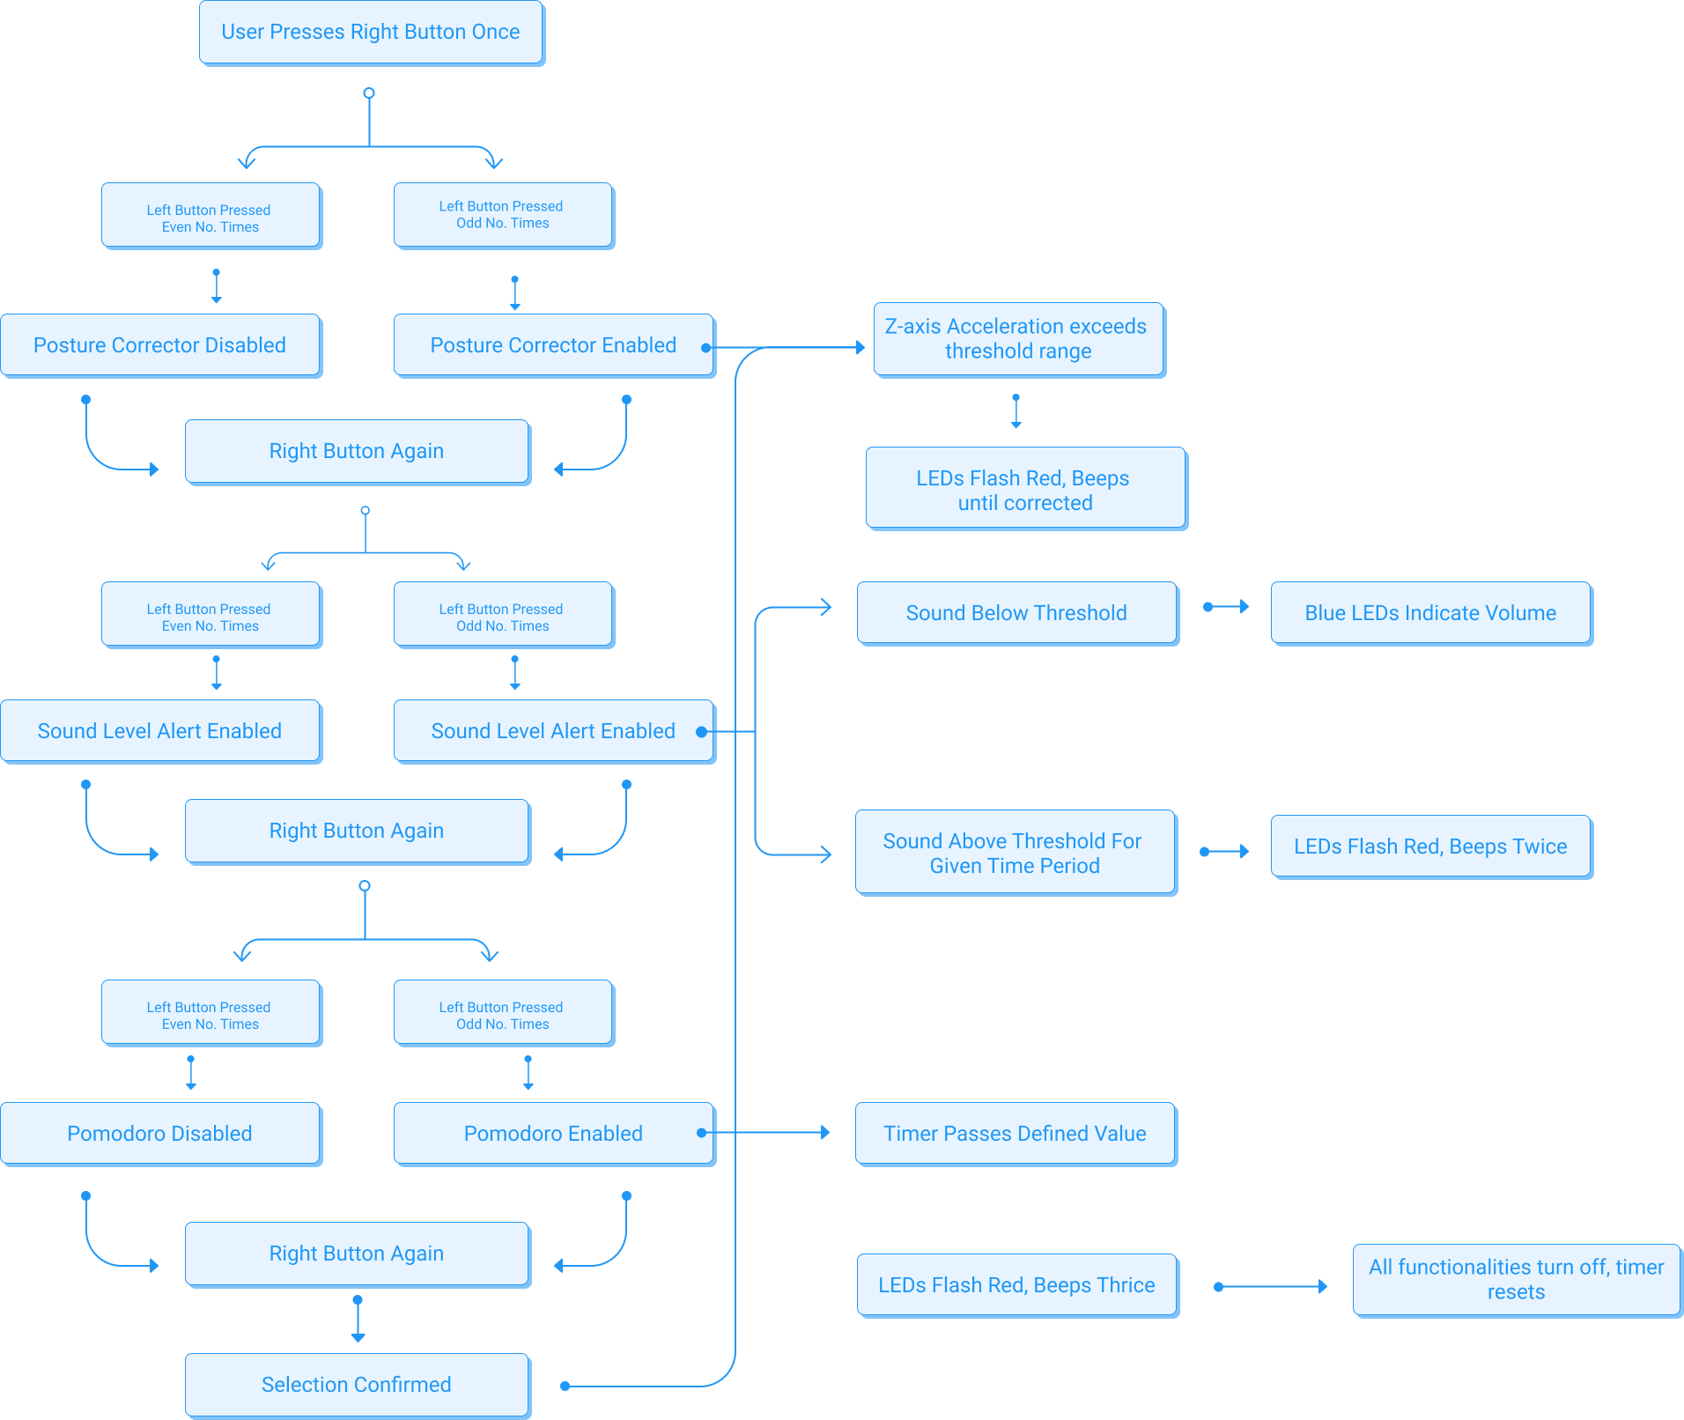
​​

Result and Evaluation
The functionalities of the device were evaluated extensively through trial-and-error testing, primarily using the serial monitor for real-time feedback. Each feature was tested individually and in combination with others to ensure proper integration and functionality under various scenarios.
Posture Correction:
The accelerometer readings for the Z-axis were monitored in the serial output to validate the threshold logic for detecting poor posture. We observed the raw Z-axis values during different movements and postures, fine-tuning the zThreshold parameter for optimal sensitivity. Overall, the device worked as intended where the user is alerted if they slouch to beyond a certain level.
Sound Level Detection:
Sound levels were monitored and compared against the threshold value. Using the serial monitor, we validated the accuracy of the average sound level calculations by comparing different amplitudes of sounds. The LED mapping was verified similarly to ensure that the appropriate number of blue LEDs were lit.
This portion of the project consumed the most time due initial errors in sound-pressure-level calculations as well as issues with the Adafruit device itself. We resolved these issues with the help of the lab instructors as well as online resources which showed better methods of calculating sound pressure levels.
Pomodoro Timer:
The timer functionality was tested using shorter intervals to verify timely alerts. Debugging challenges included ensuring that alerts were triggered consistently at the correct intervals. Additionally, interactions with the mute feature were tested to confirm that all alerts were suppressed during the break period.
User Interaction Testing:
The configuration process was thoroughly tested to ensure intuitive feature selection using the left and right buttons. Using the serial monitor, we tracked button press states and LED color changes to confirm accurate user feedback. Challenges included debouncing button presses to prevent unintended state changes, which were mitigated by introducing a delay in button state handling.
Overall, the Posture Smart device can be classified as successful as all the functions we had envisioned work as expected. Even if all 3 features were simultaneously activated by the user, the device had no problem detecting posture, sound levels and sending the reminder when needed.
Test Cases: As mentioned previously, all the features were tested multiple times, below are links to video demonstration of Posture Smart device.
Posture Correction: PostureCorrector.mp4
Sound Level and User Interface: SoundLevel.mp4
Pomodoro Timer: POSTURESMARTPomodoro.mp4

Conclusion and Future Work
The potential for future improvements to our project is vast, and several key enhancements have been identified to elevate its functionality:
- Attach a Portable Power Source
Adding a rechargeable battery system would enable users to carry the device anywhere, removing the dependency on a fixed power supply. This improvement would increase the device's usability in various environments, such as libraries, coffee shops, or outdoor study areas.
- Incorporate Health Monitoring Features
Sensors for heart rate, oxygen saturation (SpO2), and pressure monitoring could be added to provide real-time feedback on the user’s physical state. These features would help users recognize signs of fatigue or stress and make necessary adjustments to their study routines, promoting better health alongside productivity.
- Design a Protective and Fashionable Casing
Developing a sturdy casing would protect the device from physical damage, increasing its longevity. A sleek and stylish design could also enhance the product’s visual appeal, making it more attractive to users and aiding in its marketing efforts.
- Build a Mobile Application
A dedicated app would allow users to track their posture, productivity, and overall study habits. It could offer personalized insights, reminders, and suggestions to improve efficiency, creating a seamless and user-friendly experience.
- Marketing
Proper marketing will be needed to launch this as a product since its application is targeted for a particular audience i.e. students, even though it can be used by anyone to correct their posture too. This requires funding and branding strategy.
In summary, our project highlights the seamless integration of hardware and software to tackle real-life challenges. Using C++ and the Adafruit Circuit Playground, we developed features like posture correction, sound level monitoring, and break reminders, all aimed at enhancing well-being and productivity. This work reflects our ability to transform classroom concepts into a practical and meaningful application.

Reflection on Learning
This project has been an invaluable learning experience for our team, providing us with insights into conducting thorough research and applying technical concepts to address real-world problems. We began by gathering and analyzing background data to establish key parameters for our project, such as the optimal duration for the Pomodoro timer and the ideal noise levels for focus. Studies suggest that an environment with noise levels between 50 to 70 decibels fosters optimal concentration (Hongisto et al., 2016), which informs our focus mode settings. Additionally, research on productivity supports 25–30-minute focus intervals as the most effective for sustaining attention, aligning with our Pomodoro timer design (Cirillo, n.d.).
In addressing a prevalent issue among students—maintaining proper posture during extended study sessions—we recognized the importance of raising awareness and providing practical tools to mitigate health risks. By integrating a posture monitoring system, we not only tackled a common challenge but also fulfilled a sense of social responsibility by promoting healthier habits among students.
From a technical perspective, this project allowed us to apply classroom concepts to real-world applications. Leveraging C++, a language that offers direct hardware manipulation and efficient memory management, we employed object-oriented programming to decompose the system into manageable components. This approach facilitated the design and implementation of a robust and scalable solution.
Working with the Adafruit Circuit Playground introduced us to Arduino, a versatile platform with a broad range of potential applications. Arduino's flexibility enables projects beyond posture correction, such as IoT systems for home security, automated gardening, thermostats, and even healthcare solutions like medication reminders. This exposure has broadened our understanding of how embedded systems can be leveraged in diverse domains.
Overall, this project has been a comprehensive learning journey, enriching our technical skills, research capabilities, and awareness of societal needs. It underscores the potential for engineering solutions to make meaningful contributions to everyday life.

Citations
- Adafruit. (2016). Introducing Circuit Playground: Overview. Adafruit Learning System. Retrieved from https://learn.adafruit.com/introducing-circuit-playground/overview
- Arduino. (n.d.). Debounce. Retrieved from https://docs.arduino.cc/built-in-examples/digital/Debounce/
- Arduino. (n.d.). IDE 2 Serial Monitor Tutorial. Arduino Documentation. Retrieved December 10, 2024, from https://docs.arduino.cc/software/ide-v2/tutorials/ide-v2-serial-monitor/
- Cirillo, F. (n.d.). The Pomodoro Technique. https://francescocirillo.com/pages/pomodoro-technique
- Cleveland Clinic. (n.d.). Posture and its importance. https://my.clevelandclinic.org/health/articles/posture
- Dolphens, M., Cagnie, B., Coorevits, P., Vleeming, A., Vanderstraeten, G., & Danneels, L. (2012). Classification system of the sagittal standing posture in young adolescents. European Spine Journal, 21(4), 711–719.
- Hongisto, V., Haapakangas, A., Varjo, J., Helenius, R., & Koskela, H. (2016). Refurbishment of an open-plan office – Environmental and job satisfaction. Journal of Environmental Psychology, 45, 176-191.
- Lompoc Valley Medical Center. (2021). Importance of good posture. https://www.lompocvmc.com/blogs/2021/april/importance-of-good-posture/
- Louw, Q. A., Morris, L. D., & Grimmer-Somers, K. (2007). The prevalence of low back pain in Africa: A systematic review. BMC Musculoskeletal Disorders, 8(105). https://doi.org/10.1186/1471-2474-8-105
- LWW Journal. (2023). The importance of body posture in adolescence and its effect on cognitive tasks. https://journals.lww.com/imsp/fulltext/2023/14040/the_importance_of_body_posture_in_adolescence_and.3.aspx
- National Geographic. (n.d.). How posture affects health. https://www.nationalgeographic.com/science/article/how-posture-affects-health
- Nault, M. L., Allard, P., Hinse, S., Le Blanc, R., & Caron, O. (2002). Relationship between standing stability and body posture parameters in adolescent idiopathic scoliosis. Spine, 27(17), 1911–1917.
- Nelson, C. (n.d.). Circuit playground beep beep. Adafruit Learning System. https://learn.adafruit.com/circuit-playground-beep-beep
- Nissinen, M., Heliövaara, M., Seitsamo, J., & Poussa, M. (1993). Anthropometric measurements and scoliosis in prepubertal children. Spine, 18(1), 8–13.
- Peper, E., Lin, I.-M., Harvey, R., & Perez, J. (2014). Posture and mental state study. https://pubmed.ncbi.nlm.nih.gov/25222091/

